**Classic Continental Breakfast**

Assorted breakfast pastries, includes breakfast breads, coffee cakes, scones, Danish and cinnamon rolls. Chilled bottled juices include orange, apple, and cranberry. Regular, decaf coffee, and a variety of hot tea

**Lunch Buffet** - Includes assorted canned soda and cookies or brownies

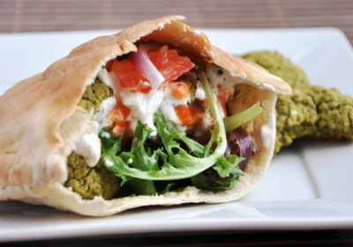**Felafel** - traditional falafel patties topped with Tadziki sauce and layered with leaf lettuce and tomatoes served in a warm pita pocket.

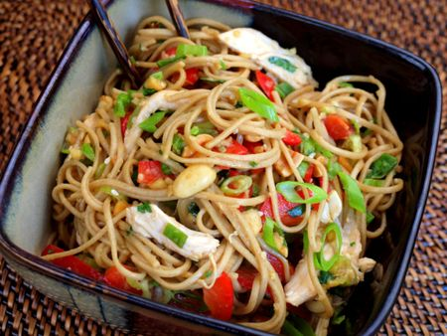

**Asian Noodle Salad with Grilled Chicken** - house made sesame noodle salad with red bell peppers and scallions served on a bed of mixed greens topped with grilled chicken breast.



And a side of mac and cheese