Special Services Unit
Fall 2016 Newsletter

Thank You for Your Survey Participation

In the last issue of our Special Services newsletter we included a patron satisfaction survey. More than 200 patrons responded. The results were overwhelmingly positive, with 201 reporting they are satisfied with the materials they receive from the library, 189 satisfied with the quantity of books they receive, and 181 rating their overall service as excellent. Thank you for taking the time to fill out and send in your surveys and for your many comments. Your feedback is invaluable to our staff.

The End of Cassettes

For many months we have been withdrawing our four-track cassette books – also known as RCs – as these older titles are being digitized and added to the digital book collection. In May, with 38,000 RC titles still remaining on our shelves, we ramped up this process with help from the National Library Service (NLS), other state library staff and our local post office, and are pleased to announce that the last of the RCs left our building on September 1.

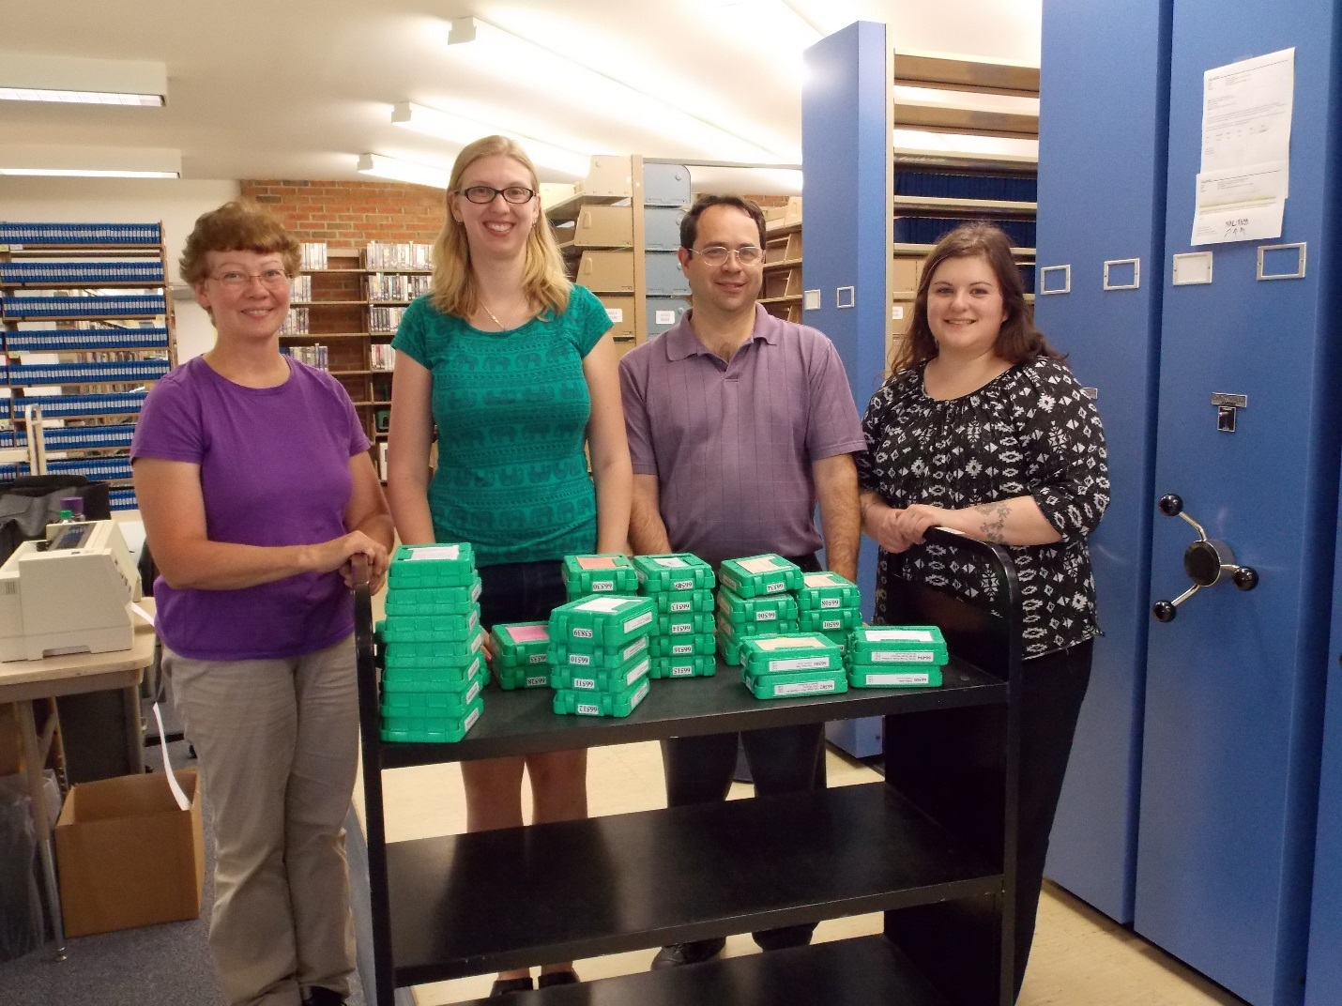
Department of Libraries staff (left to right) Sara Blow, Sara Walker, Vance Asselin and Jennifer Johnson prepare to ship out the last of the cassette books. It took several months and a lot of hard work, but we are done!

If a book you want is only available as a cassette, we will request it for you through interlibrary loan. Give us a call if you no longer feel you are receiving enough books now that cassettes are not being sent. We are happy to adjust the number of digital books you receive to meet your reading needs. Also, we encourage you to return your yellow four-track cassette players if you are no longer using them.

Two New Locally-Recorded Books Now in Circulation

We have just put into circulation two more locally-recorded Vermont books:

Something Abides: Discovering the Civil War in Today’s Vermont (VTD7), by Howard Coffin, takes readers through every town in the Green Mountain State documenting some 2,500 extant sites that were in some way touched by the Civil War. Foreword by Vermont Governor Peter Shumlin.

The Essential Bernie Sanders and His Vision for America (VTD18), by Jonathan Tasini, draws from the speeches, statements and interviews of Bernie Sanders to give readers a comprehensive understanding of Sanders’ vision for America.

In addition, the Andrew Heiskell Braille and Talking Book Library in New York City has recently made available Truesight (DBC1380), the first book in a young adult science fiction trilogy by Vermont author David Stahler, about a futuristic, distant world in which blindness is a virtue and those who see are aberrations. Books two and three, The Seer and Otherspace respectively, are in the process of being recorded here.

Our local recording program makes available books and magazines of Vermont interest that are not in the national collection. This includes books by Vermont authors, books set in Vermont, and books on topics of importance to Vermonters.

We currently have seven other locally-recorded books in circulation: Invasion on the Mountain, Trouble on the Mountain, and At the Top of the Mountain, a historical fiction trilogy by Vermont author Judith Edwards; My Name Is Jody Williams, by Vermont native and Nobel Peace Prize laureate Jody Williams; Dateline Vermont, by former Associated Press Vermont Bureau Chief Chris Graff; High-Altitude Woman, by Stowe author and adventurer Jan Reynolds; and Vermont Curiosities: Quirky Characters, Roadside Oddities and Other Offbeat Stuff, by Vermont humorist Robert F. Wilson. All of our locally-recorded books are also available for download through our online catalog: http://webopac.klas.com/vtssu. Please call the library if you want to use our catalog and don’t know your user ID or password.

More New Titles from Our Collection

Adult Fiction:

The Last Mile, by David Baldacci. DB 83898
As Melvin Mars is about to be executed for the violent killing of his parents two decades earlier, another man confesses to the crime. Meanwhile, Amos Decker takes an interest in Mars's case after discovering striking similarities to his own life. Unrated. Commercial audiobook.

The Japanese Lover, by Isabel Allende. DB 84043
San Francisco, 2010. A young Moldovan worker, Irina Bazili, encounters Alma Belasco in the Lark House nursing home. Irina uncovers the story of Alma's hidden relationship with Ichimei, the son of her family's gardener, which spanned nearly seventy years. Bestseller.

Fool Me Once, by Harlan Coben. DB 84266
Maya Burkett, a former army captain who suffers from PTSD, has just buried her murdered husband when she sees him on her nanny cam. Meanwhile, she investigates why her sister was shot down four months earlier with the same gun. Strong language and some violence. Bestseller.

Adult Nonfiction:

Rosemary: The Hidden Kennedy Daughter, by Kate Clifford Larson. DB 83946
Historian profiles the little-known older sister of President John F. Kennedy, whose intellectual disabilities were kept secret. Using diaries and correspondence, school and doctors' letters, and family interviews, details the care Rosemary received and the decision to lobotomize her at age twenty-three. Bestseller.

And Then All Hell Broke Loose: Two Decades in the Middle East, by Richard Engel. DB 84514
Chief foreign correspondent for NBC chronicles his experiences reporting in the Middle East since 1997, when he was a young man fresh out of college. Recounts stories of the people he has encountered, including everyday people, rebels, and dictators. Discusses the political changes he has seen. Some violence. Bestseller.

Children’s Books:

The Worst Class Trip Ever, by Dave Barry. DB 82737
When Culver Middle School's eighth-grade class travels to Washington, D.C., Wyatt finds himself in trouble before the plane even lands. His best friend, Matt, has decided the men sitting behind them are terrorists, and it is up to the boys to stop them. For grades 5-8.

We Rock! A Fun Family Guide for Exploring Rock Music History, by Jason Hanley. DB 82889
A family listening guide to the evolution of rock music and subgenres, featuring artists such as Elvis Presley, the Supremes, Led Zeppelin, Queen, Blondie and more. Provides historical background for each artist and group, and includes playlists, labs, and music-centered destinations for vacation ideas. For grades 4-7 and older readers.

The Armpit of Doom: Funny Poems for Kids, by Kenn Nesbitt. DB 83187
Collection of seventy poems by the Poetry Foundation Children's Poet Laureate (2013-2015). In "My Parents Sent Me to the Store," a child rejects his parents' shopping list and instead comes home with a gaggle of new pets. For grades 2-4.

NLS Music Division

As a patron of our library you have access to more than 30,000 music scores, instructional materials and music appreciation books in braille, large print and digital audio through the National Library Service. Sheet music is available in both braille and large print, and biographies and other books about popular and classical musicians are available in large print and digital audio. The collection is also available on BARD, and NLS will transfer books to digital cartridge for any patron upon request. To access this collection, visit http://nlscatalog.loc.gov. To place orders for any of these materials, call the NLS Music Section directly at 1-800-424-8567.

Talking Book Topics Change

To better accommodate the needs of subscribers to the audio version of the bi-monthly Talking Book Topics catalog, NLS will resume circulating the magazine cartridge and order form in the same package, beginning with the September-October 2016 issue. The magazine cartridge and order form will still need to be returned separately, however, with the cartridge going back to the producer in its red container and the order form being mailed directly to us at the Special Services library.

High Volume Player and Headset

NLS has developed a high-volume version of the digital talking book player for use by patrons who are severely hearing impaired. The high-volume player is paired with a headset and is available as a standard or advanced model that has been programmed to have an amplified volume up to 120 decibels. The high-volume feature only works when using the high-volume player and specialized NLS-supplied headset. The pairing replaces the amplifier/headset accessory currently in use.

If you would like to receive a high-volume player and headset, you must provide certification of severe hearing impairment by a physician or audiologist. We have application forms and will forward complete certified applications to NLS for patrons. The player and headset will be shipped directly to the patron from NLS. Call us at 1-800-479-1711 for more information.

Tech Talk – Assistive Technology

Assistive Technology (AT) devices help a person complete a task they might otherwise need help to do. AT devices run the gamut from high-tech computer hardware and software to simple low-tech devices such as a “grabber” used to reach an item that is on a high shelf.

Vermont has a very active Assistive Technology Program which is part of the Vermont Department of Disabilities, Aging and Independent Living based in Waterbury. They run three Vermont Assistive Technology Tryout Centers in Waterbury, Rutland and Burlington. These Tryout Centers provide demonstrations, short-term equipment loans, group trainings and technical assistance around the latest technology. Their services are available to consumers, caregivers, educators and service provider teams. To request more information contact them at 1-800-750-6355 or by email at dail.atinfo@vermont.gov.

BARD Updates

The BARD Mobile app for Android devices can now be downloaded to any second generation Kindle Fire device. The app is available for free on Amazon. If you are having trouble using BARD on any Android device, including the Kindle Fire, make sure you have version 1.0.2 downloaded. This update requires Android OS 4.1 or later.

BARD has been updated for those with iOS devices as well. The App Store now has version 1.1 available. This release is packed with features, including a sleep timer, enhanced braille search, improved Magic Tap response and more, and is compatible with iOS9.

Currency Reader Program

If you are having problems with your iBill currency reader, please call the Bureau of Engraving and Printing (BEP) Call Center toll-free at 1-844-815-9388. BEP staff members can help you troubleshoot issues and can also authorize the delivery of a replacement device, if necessary. If you do not have a currency reader and are interested in getting one, please call the number above or visit their website at http://www.bep.gov/uscurrencyreaderpgm.html to request an application. The currency reader assists individuals in identifying U.S. currency and is available free to any legal resident of the United States who is unable to read regular print because of blindness or visual impairment.

Returning Books

Please check around your house for any talking books and/or book mailing cases that need to be returned. Also, please check to make sure you are returning the right book in the right case. There has been an increase in the number of digital books returned with the wrong cartridge in the container, which prevents both books from being circulated to other patrons until they can be matched up with their correct mates. Please also make sure you are not returning empty cases. We recommend placing the cartridge back in its container before switching to another book. Your diligence in this matter is most appreciated!

Returning Machines

It is much easier to return a digital or cassette player if you have kept the original box and packing materials. Turn over the preprinted card on the outside of the box for the return address. You can use another box, if you don’t have the original, but please pack the machine carefully and mark “Free Matter for the Blind” where postage normally goes. It is helpful to call us before you return the machine and/or to fill out the form enclosed with the machine so we know why the machine is being returned, especially if you need a replacement.

Change of Address?

To ensure your delivery of books is not interrupted, please notify us if you have a change of address. If you are going to be at a temporary address for a month or more – heading south for the winter, for example – let us know that, as well. We can send your books to your temporary address. If you are permanently moving outside of the state of Vermont, notify us in advance of your move so that we can send the necessary paperwork to your new home state. We don’t want you to be without a good book to read!

Reduced Library Hours and Voicemail

Just a reminder that we now have reduced hours for walk-in service. We are open Tuesday, Wednesday and Thursday from 9:30am to 3pm; closed Monday and Friday. We are still open for telephone service Monday through Friday, 7:45am to 4:30pm, at 802-828-3273 or 1-800-479-1711. If we are unable to get to the phone we do have voicemail, so it is fine to leave us a brief message any time of the day or night, including your book requests. Please make sure you include your name, reason for calling, and phone number if you require a return call. We will get back to you within one business day.

Spread the Word!

If you know of any friends or relatives who may qualify and benefit from our services, please give them our phone number (802-828-3273 or
1-800-479-1711). We work hard at promoting our services, but we can always use your help and support with spreading the word! We are also happy to send out extra applications to any facility or institution that serves individuals who qualify. Please let us know if you have any ideas or suggestions as to how we may better reach potential patrons.

Holiday Closings

Veterans Day – Friday, November 11, 2016
Thanksgiving – Thursday, November 24 & Friday, November 25, 2016
Christmas – Monday, December 26, 2016
New Year’s – Monday, January 2, 2017
Martin Luther King Day – Monday, January 16, 2017

Vermont Department of Libraries, Special Services Unit
1-800-479-1711 or (802) 828-3273
Monday-Friday, 7:45 am to 4:30 pm
Email lib.ssu@vermont.gov
Website libraries.vermont.gov/library_for_the_blind
Online catalog webopac.klas.com/vtssu
This newsletter is available in alternative formats upon request.
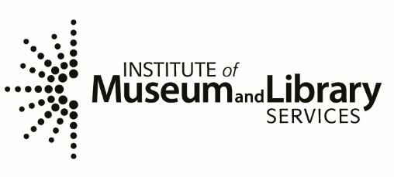

This program is supported in part by the
Institute of Museum and Library Services, a federal agency, through the
Library Services and Technology Act.

