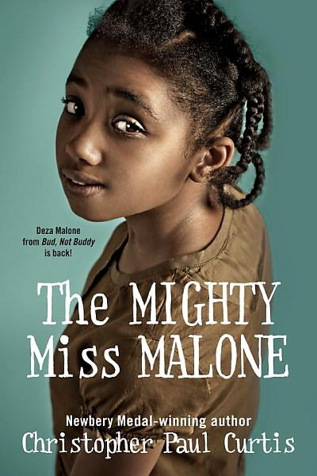
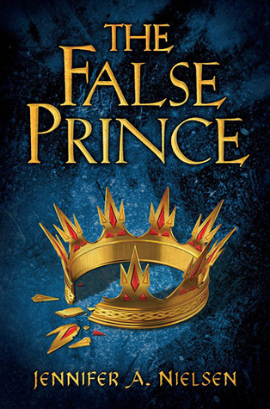
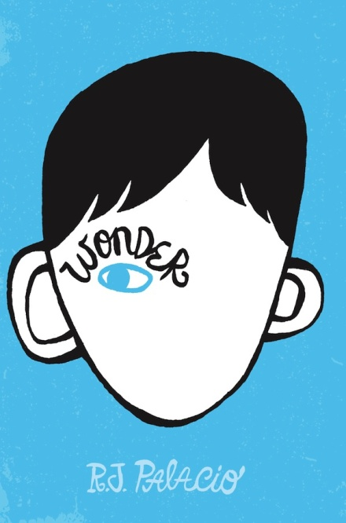

THE 2017-2018
GREEN MOUNTAIN BOOK AWARD CHECKLIST

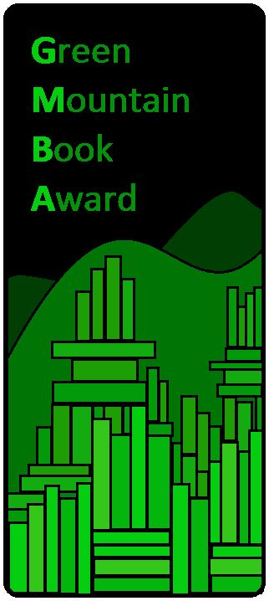

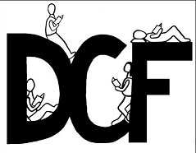

Sponsored by the
Vermont Department of Libraries

http://bit.ly/2rwNnSX

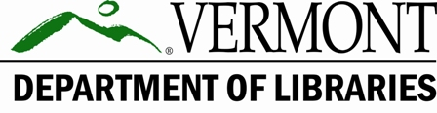

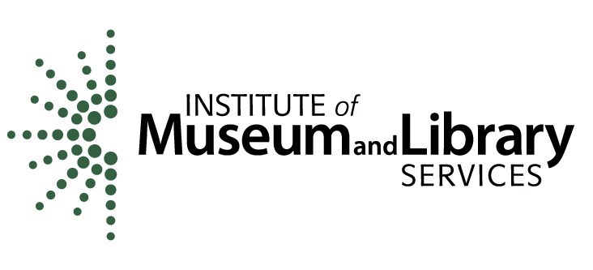

GMBA BOOKS
2017-2018

Use this list to keep track of the books as you read them.
- THE HATERS
Jesse Andrews
- LAST OF THE GIANTS: THE RISE AND FALL OF EARTH’S MOST DOMINANT SPECIES
Jeff Campbell. Illus. Adam Grano
- THICKER THAN WATER
Kelly Fiore
- ROLLING BLACKOUTS: DISPATCHES FROM TURKEY, SYRIA, AND IRAQ
Sarah Glidden
- STEEPLEJACK
A.J. Hartley
- RADICAL
E.M. Kokie
- MY SISTER ROSA
Justine Larbalestier
- WRECKED
Maria Padian
- RED PLATOON: A TRUE STORY OF AMERICAN VALOR
Clinton Romesha

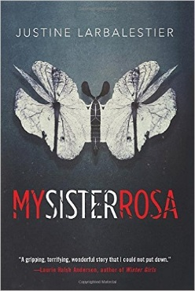
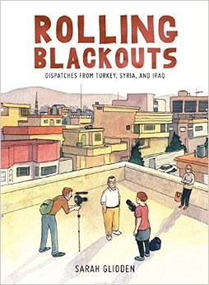

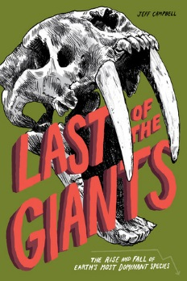
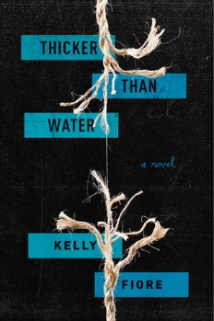
- IF I WAS YOUR GIRL
Meredith Russo
- SALT TO THE SEA
Ruta Sepetys
- SCYTHE
Neal Shusterman
- 23 MINUTES
Vivian Vande Velde
- THE SUN IS ALSO A STAR
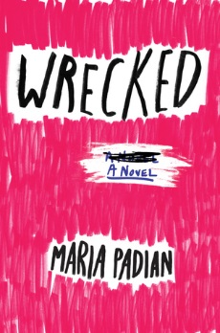
Nicola Yoon
- THE SERPENT KING
Jeff Zentner

