Green Mountain Book Award Master List 2017-2018

These books, to be read during the 2017-2018 school year, comprise the master list for the award to be given in 2018. Voting forms will be made available to all Vermont schools and public libraries in the spring so that young adults can vote for their favorite book. The master list titles have been selected to satisfy the reading interests of teens in grades 9-12, and include both adult and young adult books. All books on the list were first published in 2016.

Andrews, Jesse. The Haters. Abrams, 2016. $18.95. ISBN 978-1419720789.
Wes and best friend Corey decide to take their music to the next level at jazz camp. When they meet Ash, and find camp too lame for their sound, they take their new band on the road trip of a lifetime.

Campbell, Jeff. Illus. Adam Grano. Last of the Giants: The Rise and Fall of Earth’s Most

Dominant Species. Zest Books, 2016. $13.99. ISBN 978-1942186045.

A fascinating study of giant species like the auroch, the moa, the elephant bird, and their extinction during the last 500 years. Biology, history, geology, and zoology skillfully intermingled.

Fiore, Kelly. Thicker Than Water. HarperTeen, 2016. $17.99. ISBN 978-0062324733.
Cecilia Price was planning to go to college and leave her poor, rural town. Plans changed when she killed her brother and addiction destroyed the fabric of her family.

Glidden, Sarah. Rolling Blackouts: Dispatches from Turkey, Syria, and Iraq. Drawn

and Quarterly, 2016. $24.95. ISBN 978-1770462557.

What is Journalism, and why is it important? These were the questions that Sarah wanted to answer when she joined her friends on a trip to the Middle East to research potential stories of refugees from the Iraq War. In this graphic memoir, Glidden shares her observations.

Hartley, A.J. Steeplejack. Tor Teen, 2016. $17.99. ISBN 978-0765383426.

Ang works as a steeplejack in a 19th century South African city, cleaning and fixing chimneys and towers. Through this work, she learns of many dark secrets of Bar-Salem. When thievery and a murder coincide, Ang can't help but get swept up in solving the mystery.

Kokie, E.M. Radical. Candlewick, 2016. $17.99. ISBN 978-0763669621.

Bex is a doomsday prepper. She is ready for the end of the world. Until she meets Lucy, who makes Bex re-evaluate what she wants out of her life.

Larbalestier, Justine. My Sister Rosa. Soho Teen, 2016. $18.99. ISBN 978-1616956745.

Che's main role in life is to keep his ten-year-old sister under control. Rosa is smart, cute, talented, and also appears to be a psychopath.

Padian, Maria. Wrecked. Algonquin, 2016. $17.95. ISBN 978-1616206246.
Haley is a college freshman whose soccer career has just ended. Richard is sophomore math major. Jenny is Haley’s friend who is raped at a party in Richard’s house. Told in alternate chapters from Richard and Haley, Wrecked tells a realistic story of the aftermath of an on-campus rape.

Romesha, Clinton. Red Platoon: A True Story of American Valor. Dutton, 2016. $28.00. ISBN: 978-0525955054.

In 2009, Clinton Romesha was a member of Red Platoon and posted to Command Outpost (COP) Keating in Afghanistan. Red Platoon is the story of the 14-hour battle over COP Keating and the men who fought in it.

Russo, Meredith. If I Was Your Girl. Flatiron Books, 2016. $17.99. ISBN 978-1250078407.

Before Amanda moved to small-town Tennessee, she was Andrew, the boy who wants to be a girl. Now she is her true self, grappling with the truth about her past.

Sepetys, Ruta. Salt to the Sea. Philomel, 2016. $18.99. ISBN 978-0399160301.

Four teens, Emilia, Florian, Alfred, and Joana, must face the terrifying odds of survival in this historical novel set in East Prussia at the end of World War II.

Shusterman, Neal. Scythe. Simon & Schuster, 2016. $18.99. ISBN 978-1442472426.
Humanity has conquered disease and death. Now, the population can only be controlled through Scythes, actors who have the authority and the ability to kill when your number is up. Two teens, Citra and Rowan, are chosen to apprentice a Scythe, but only one will become a master of death.

Vande Velde, Vivian. 23 Minutes. Boyds Mills Press, 2016. $16.95. ISBN 978-1629794419.

If Zoe says "replay!" the events of the last 23 minutes do just that. It's a great gift to have when a friendly man is killed during a bank robbery – but she has no control over the way the events replay, and only ten tries to save him.

Yoon, Nicola. The Sun Is Also a Star. Delacorte, 2016. $18.99. ISBN 978-0553496680.

Natasha believes in the science and the power of reason to make the world a better place. On her last day and last ditch efforts not to get deported, she meets Daniel, a dreamer and a poet whose optimism and belief in fate just might change her life.

Zentner, Jeff. The Serpent King. Crown, 2016. $17.99. ISBN 978-0553524024.

Dill, the son of a snake-handling preacher, and his two outcast friends, Travis & Lydia, try to survive their senior year in a rural Tennessee town. Each has a dream for the future they hope to see realized, but can they keep it together long enough to reach the world outside of their hometown?

Green Mountain Book Award Committee Chair  Kara Rosenberg  U-32 Junior/Senior High School  930 Gallison Hill Road  Montpelier, VT 05602  kara.s.rosenberg@gmail.com | Department of Libraries Contact  Jennifer Johnson, Library Advancement Assistant  Vermont Department of Libraries  109 State St.  Montpelier, VT 05609  (802) 828-2721  jennifer.johnson@vermont.gov

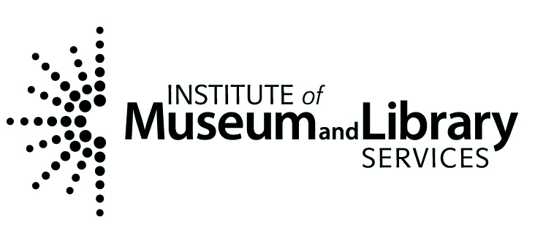 | This publication is supported by the Institute of Museum and Library Services, a federal agency, through the Library Services and Technology Act.

