HeritageQuest

HeritageQuest is a geneaology web service offered by the Department of Libraries to all public libraries in the state. It is maintained by ProQuest, and uses data from Ancestry.

What Link Should We Give to Patrons?

Libraries should use a link that includes their library code; without the library code, patrons may be able to login (with a password), but they won’t be counted for your statistics.

http://www.heritagequestonline.com/ipbarcode?aid=LibraryCode

How Do Users Get Access to the Site?

If the user is inside the library, and the library’s IP address is on file, then they should be recognized immediately.
If the user is inside the library, the library’s IP address should be on file, so they should be recognized immediately.

How Do I Access Stats for HeritageQuest

https://www.heritagequestonline.com/localadminweb/hqousagereport/do/report?pid=LibraryCode

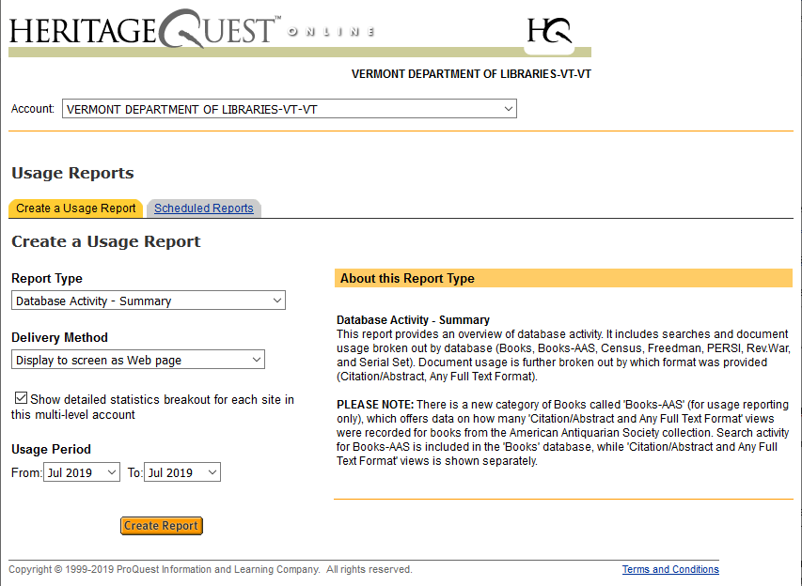

Included Data:

- Census collection contains over 700 million records from the U.S. Federal Census 1790-1940, and national censuses including Argentina, Netherlands, Czech Republic and several other countries.
- Books collection contains over 22,000 family and local histories, compiled genealogies, documentary collections, church records, military records, vital records, city and county histories, and more.
- City Directories with over 1.5 million records from various US city and county directories during 1821-1989.
- Military Records containing over 2 million records from selected state and country military records including the US Revolutionary War Pension and Bounty-Land Warrant Application Files 1800-1900, US Records of Confederate Prisoners of War 1861-1865, and US Remarried Widows Index to Pension Applications 1887-1942.
- Wills and Probate Records has more than 170 million pages from the largest collection of wills and probate records in the United States, with searchable records included from all 50 states spread over 337 years (1668-2005).
- Freedman’s Bank contains an index and original images of the Freedman's Savings and Trust Company's registers of Signatures of Depositors 1865-1871.
- US Serial Set (subset) contains more than 140,000 private relief actions, memorials, and petitions drawn from the records published "serial" fashion from the US Senate and House of Representatives 1769-1969.
- Maps & Photos includes US Indexed County Land Ownership Maps 1860-1910, US Enumeration District Maps and Descriptions 1940, US Indexed Early Land Ownership and Township Plats 1785-1898, and Library of Congress Photo Collection 1840-2000.

