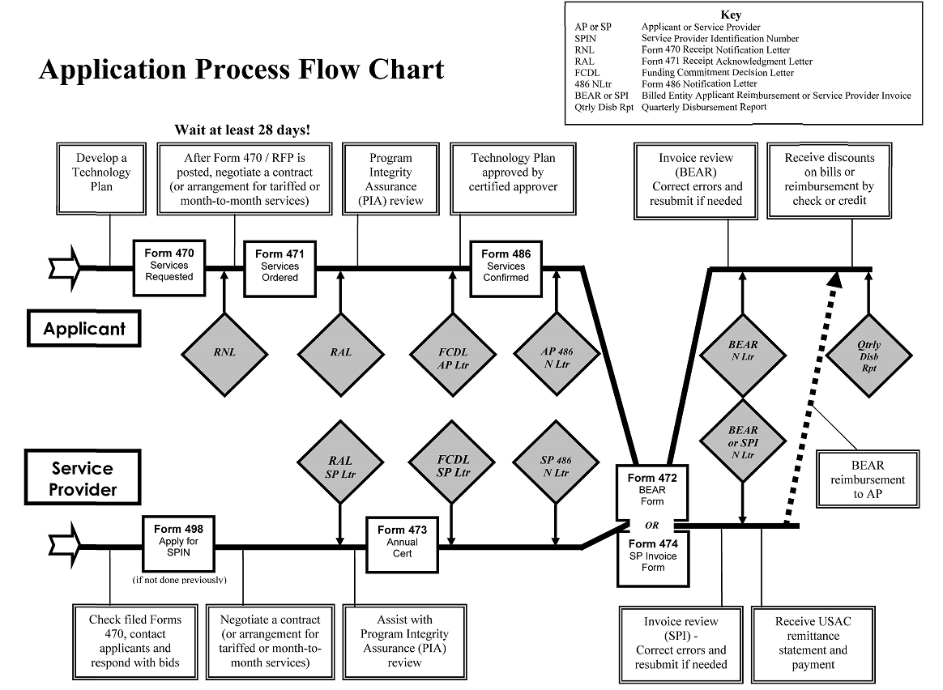
Keystones
- Form 470 - Description of Requested services
This Form opens a competitive bidding process for any services that you will submit for reimbursement under the E-Rate program. The Form 470 typically becomes available in month of July prior to the start of the Funding Year (for example – for Funding Year 2015 the Form 470 should become available in July 2014). The completed Form 470 is posted on the SLD website; you must wait a minimum of 28 days from the posting date before you select a service provider, sign a contract, enter into an agreement or file a Form 471. To file your Form 470 online click here (http://www.slforms.universalservice.org/Form470Expert/criteria.aspx?criteria=new).

Note: If you have an existing contract that covers the complete filing year or are using the Vermont State Libraries contract-you do not need to file a Form 470. If you have an existing contract that will end before the filing year ends (July through June of following year), you must file a Form 470 for the non-contracted month/s of that funding year.

- RNL – Receipt Notification Letter
Letter sent by USAC – Notifies you that your Form 470 was successfully posted and begins the 28-day competitive bidding process. This letter identifies the earliest date on which you may select a service provider and submit a Form 471. The RNL letter can be used to request corrections for clerical or ministerial errors. Corrections can be processed until the FCDL is issued.

- Form 471 – Description and certification of Services Ordered
This Form notifies the Schools & Libraries program of your intent to file for a discounted reimbursement for eligible services under the E-Rate program. The Form 471 details which service providers you have selected along with details about the services and the costs per month and/or one-time charges. The Form 471 must be posted before midnight on the day of the filing window close (this date varies from year to year and will be announced by USAC).

Additional Documentation is also submitted to support the charges on the Form 471, this is known as the Item 21 Attachment. The Item 21 Attachment provides additional details about the service that do not appear on the Form 471. These details include information such as: quantity of phone lines, type of phone lines (POTS, Centrex, VOIP), type of service, etc. The Item 21 Attachment should be sent to USAC at the same time the Form 471 is submitted, and no later than the close of the Form 471 filing window. If the Item 21 Attachment is not received, USAC will send a reminder letter and allow you to submit them at a later date. In recent Funding Years Item 21 Attachments have been in May.

Also note that USAC posts a list of FRNs missing Item 21 Attachments on its website. For Funding Year 2013 this list was posted on 4/24/13, and for Funding Year 2014 the list was posted on 5/6/14.

- RAL – Receipt Acknowledgement Letter
Letter sent by USAC - Includes a RAL Funding Request Report for each Form 471 Application and summarizes the funding information and requests for with a specific Form 471. The RAL is used to make corrections for any clerical errors. Corrections can be processed until the FCDL is issued.
- PIA Review – Program Integrity Assurance Review
After you file an FCC Form 471 and the associated Item 21 attachment(s) within the filing window, Program Integrity Assurance (PIA) reviewers at USAC check the information on your form for completeness and accuracy and may have additional questions for you to answer.

All applications go through an initial review and a final review, which may involve questions from PIA reviewers on one or more of the following topics:

- Eligibility of the entities receiving service
- Eligibility of the services requested
- Discount calculations
- Contracts
- The competitive bidding process
- Any discrepancies between the information on the funding request and the associated Item 21 attachment

Indicate your preferred mode of contact on the FCC Form 471 Item 6c (telephone), 6d (fax), or 6e (email). PIA reviewers send written questions by fax or email and they will call you and ask you for a fax number or email address if you indicate telephone as your preferred mode of contact.

See http://www.usac.org/sl/applicants/step05/default.aspx for more information about the PIA Review process
- FCDL (AP LTR) – Funding Commitment Decision Letter
Letter sent by USAC – Contains USAC’s decisions regarding your funding requests and details the approved dollar amounts for each FRN. Adjustments may be based on PIA/selective reviews, corrections and/or eligibility issues. This letter can be appealed, if appeal is filed within deadline, usually about 40 business days. See http://www.usac.org/sl/tools/deadlines/appeals.aspx for deadline calculator.

- Form 486 – Confirmation of receipt of services and program compliance
For each Funding Request Number (FRN) a Form 486 is completed to document the Initial Service Start Date (SSD). Each Form 486 also includes authorization from the Service Provider to pay the invoices submitted with Form 472 (BEAR). Click here (http://slforms.universalservice.org/Form486exp/SearchEntity.aspx) to complete the Form 486 online.
The Form 486 must be received or postmarked no later than 120 days after the Service Start Date shown on the FCC Form 486 or 120 days after the date of the FCDL, whichever is later.
If the FCC Form 486 is received or postmarked after the deadline, USAC will adjust the Service Start Date on the FRNs on the FCC Form 486 to the date 120 days before the FCC Form 486 was received or postmarked. USAC will not pay discounts on services received before this date, and the applicant's funding commitment may be reduced.
If any of the services received included Internet Access - the section certifying compliance with the Children’s Internet Protection Act (CIPA) must be completed.
Since Funding Year 2011 (FY2011), a technology plan is required only when the library is requesting funding for Priority 2 Internal Connections and/or Basic Maintenance Services. If the library requested any Priority 2 services, they must include certification of their technology plan approval with the Form 486. If no technology plan is required, enter “None” at Block 4 Line 8 on the Form 486.
- AP 486 (N LTR)- Form 486 Notification Letter
Letter sent by USAC – Confirms your Form 486 information and documents your service start date. This letter includes information about the next steps in the application process. Your Form 472 (BEAR) must be signed by you and your service provider then submitted within 120 days after the date of this letter or the last day to receive service whichever is later.

- Form 472 – Billed Entity Reimbursement (BEAR)
Once the FCDL has been issued, and the Form 486 filed, a Form 472 (BEAR) may be submitted to request reimbursement for invoices paid to each service provider listed on an FRN for that funding year. Some service providers have more than one identification numbers (SPIN); please verify that the SPIN used is correct for the services received.

To submit the Form 472, list the current charges for each month of the filing year (e.g. July 2014-June 2015). The amount listed should match the amount on that month’s invoice. Do not include any amounts carried over or unpaid from a prior month (these are included in the total amount due rather than current charges).

A separate list of any ineligible charges each month is also included. This is submitted as a total of all ineligibles for a specific month. Typical ineligibles include: Administrative fees (adm fees), late fees, property taxes, paper billing fee, directory listing, advertising fee, non-listed fee, etc. For a complete list see the Ineligible services list (http://www.usac.org/sl/applicants/beforeyoubegin/eligible-services-list.aspx)for applicable funding year.

To file the BEAR online, click here (https://www2.sl.universalservice.org/bear/login.aspx). Your BEAR may be selected for a “detailed invoice review”. If this happens, you will be required to send copies of all bills relevant the BEAR, as well as a spreadsheet that details the monthly current charges and any ineligible items that were removed from the BEAR total.

The deadline for filing BEARs is typically 120 days after the last day to receive service or 120 days after the FCC Form 486 Notification Letter date, whichever is later. If you miss this deadline you can request an invoice deadline extension (http://www.usac.org/sl/applicants/step07/invoice-extensions.aspx).

- BEAR (N LTR) – BEAR Notification Letter
Letter sent by USAC – This letter notifies you that your Form 472 (BEAR) has been processed and notes and reductions or denials. A copy is also sent to the Service Provider.

USAC typically disburses the reimbursement funds to the service provide about two weeks after the date of the BEAR Notification Letter. After the service provider has received the reimbursement funds, it has 20 business days to remit the reimbursement funds to the applicant.

- Form 474 – Service Provider Invoice (SPI)
Service providers file an FCC Form 474 (SPI Form) to request payment of the discount amount for eligible services after billing applicants for the non-discount share of the cost of those services. This billing method will need to be requested from the service provider either during contract negotiations or after receipt of the FCDL.

SPI Forms can be submitted for one-time charges or monthly, bimonthly, quarterly, or less frequently. However, the non-discount share of the cost of the services featured on the SPI Form must have been billed to the applicant.

Once the SPI invoicing method has been agreed upon, most service providers will place a credit on the monthly bill. This requires that the applicant only pay the discounted cost of the service.

The deadline for filing SPIs is typically 120 days after the last day to receive service or 120 days after the FCC Form 486 Notification Letter date, whichever is later. If the invoicing deadline is missed, the service provider must request an invoice deadline extension before a SPI Form can be resubmitted.
- QRTLY Disb Rprt – Quarterly Disbursement Report
  - Letter Issued by USAC - Details all disbursements during each calendar quarter (may include other funding years. This document allows you to track your disbursements and invoicing.

