Special Services Unit
Spring 2016 Newsletter

Farewell, Cassette Books

Due to the decrease in cassette book circulation and the National Library Service’s cassette recall, effective July 1, 2016, we will no longer be sending out cassette books. If a book you want to read is only available as a cassette, we will request it for you through interlibrary loan.

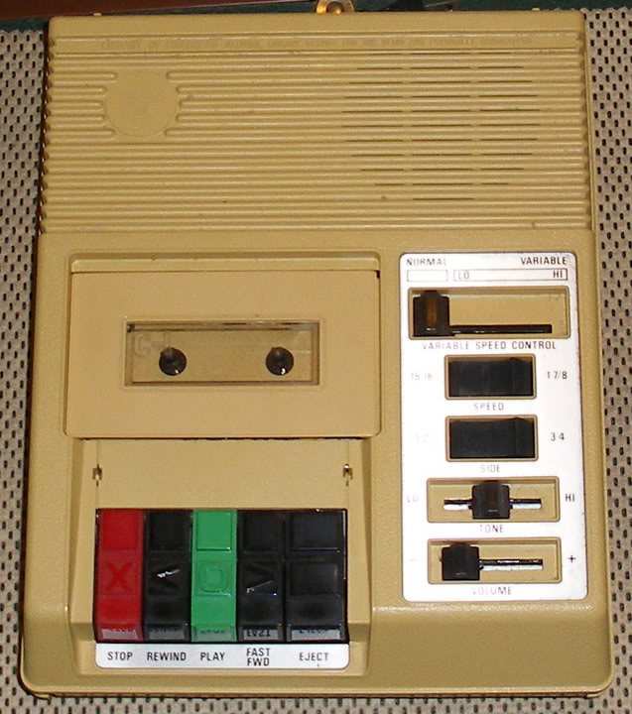
You may keep your YELLOW cassette player (pictured left) if you are still using it and it’s in good working order. If you are no longer using your cassette player, you may return it to the library in the box you received it in. If you need a mailing box to return the player, please contact us and we will send you one. We are no longer replacing cassette players returned for repair.

Please note: most of our patrons have only used the BLACK digital book player and digital cartridges since 2010. We are not asking you to send your BLACK digital book player back, and we will continue to circulate digital books that play in that machine.

Seventh Locally-Recorded Book Now in Circulation

We have just completed our seventh locally-recorded book, Vermont Curiosities: Quirky Characters, Roadside Oddities and Other Offbeat Stuff (VTD8) -- a humorous collection of Vermont personalities, roadside attractions, interesting places, events and traditions – by Robert F. Wilson. Our local recording program makes available books and magazines of Vermont interest that are not in the national collection. This includes books by Vermont authors, books set in Vermont, and books on topics of importance to Vermonters.

Six other locally-recorded books are also in circulation: Invasion on the Mountain, Trouble on the Mountain, and At the Top of the Mountain, a historical fiction trilogy by Vermont author Judith Edwards; My Name Is Jody Williams, by Vermont native and Nobel Peace Prize laureate Jody Williams; Dateline Vermont, by former Associated Press Vermont Bureau Chief Chris Graff; and High-Altitude Woman, by Stowe author and adventurer Jan Reynolds. All seven books are also available for download through our online catalog: http://webopac.klas.com/vtssu. Please call the library if you want to use our catalog and don’t know your user ID or password.

New Recording Booth Celebrated

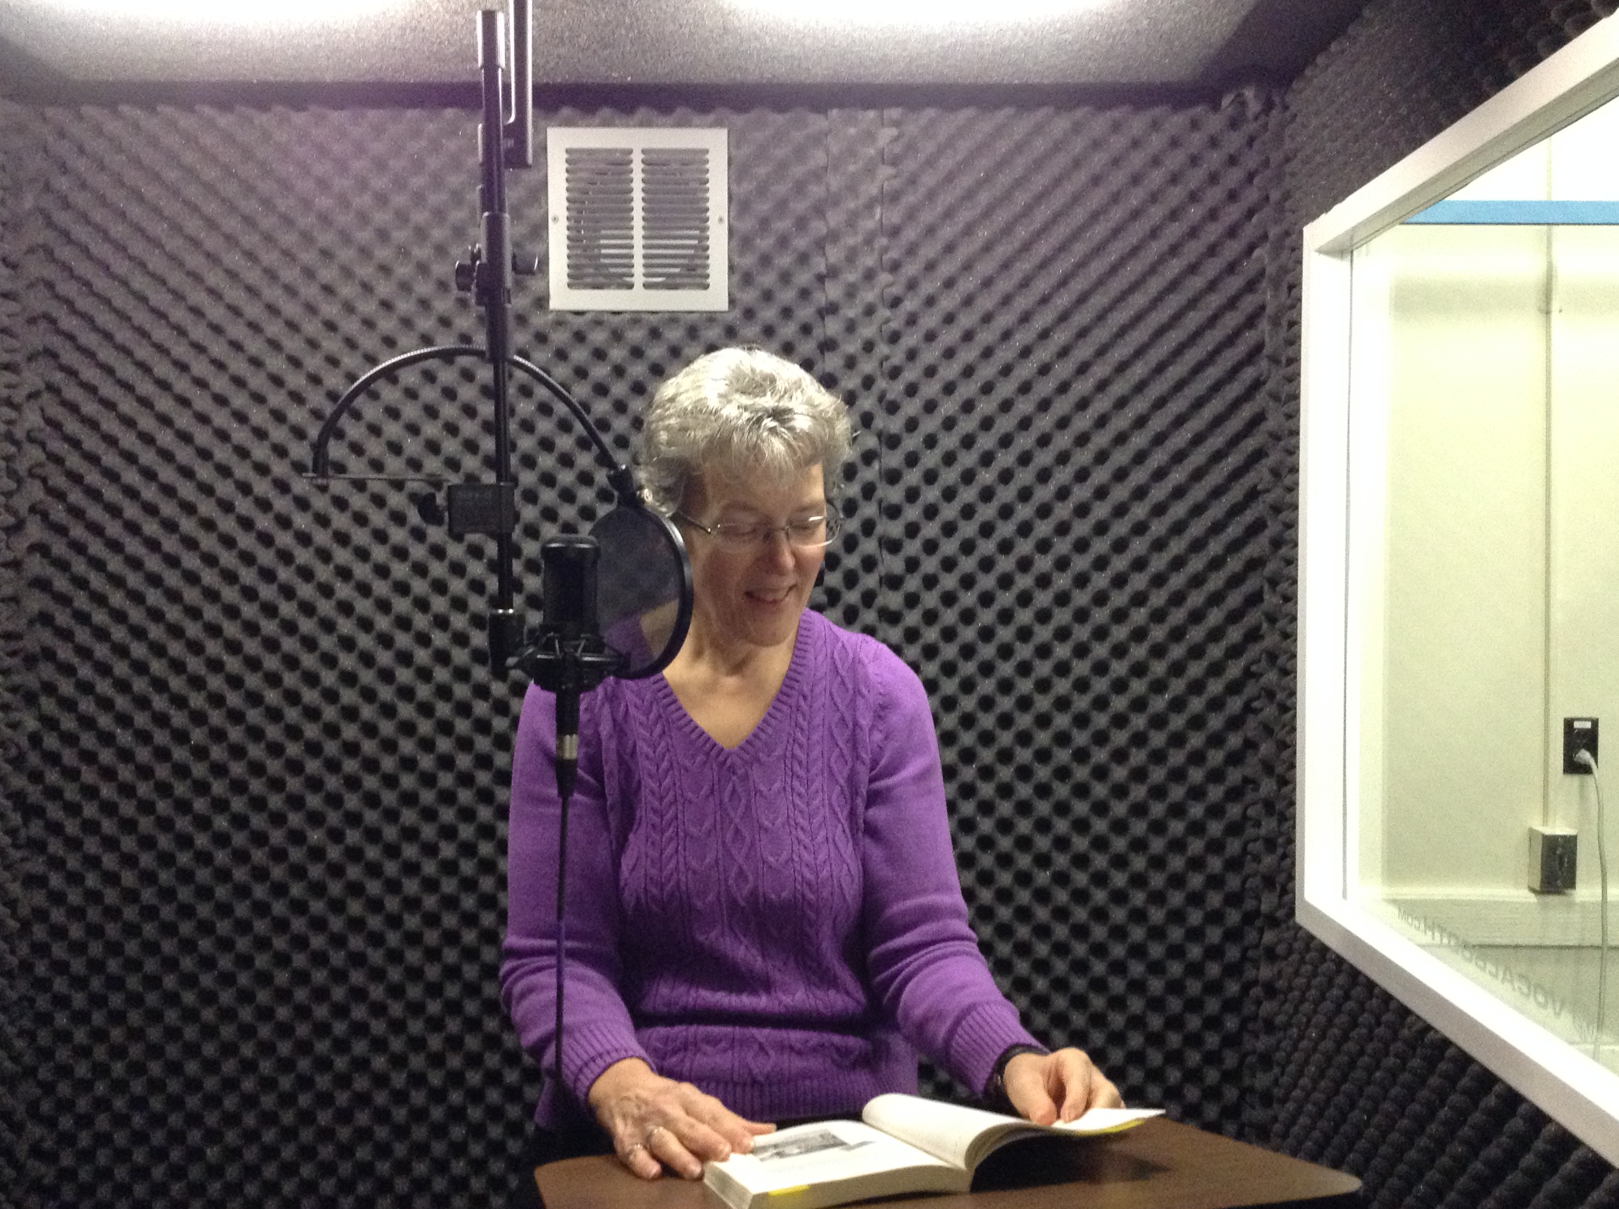
We recently acquired a professional recording booth for our local recording program. It is a free-standing, six-foot by six-foot booth, and is housed in our library building in Berlin. Staff and volunteers gathered in February to celebrate this newest addition to our program.

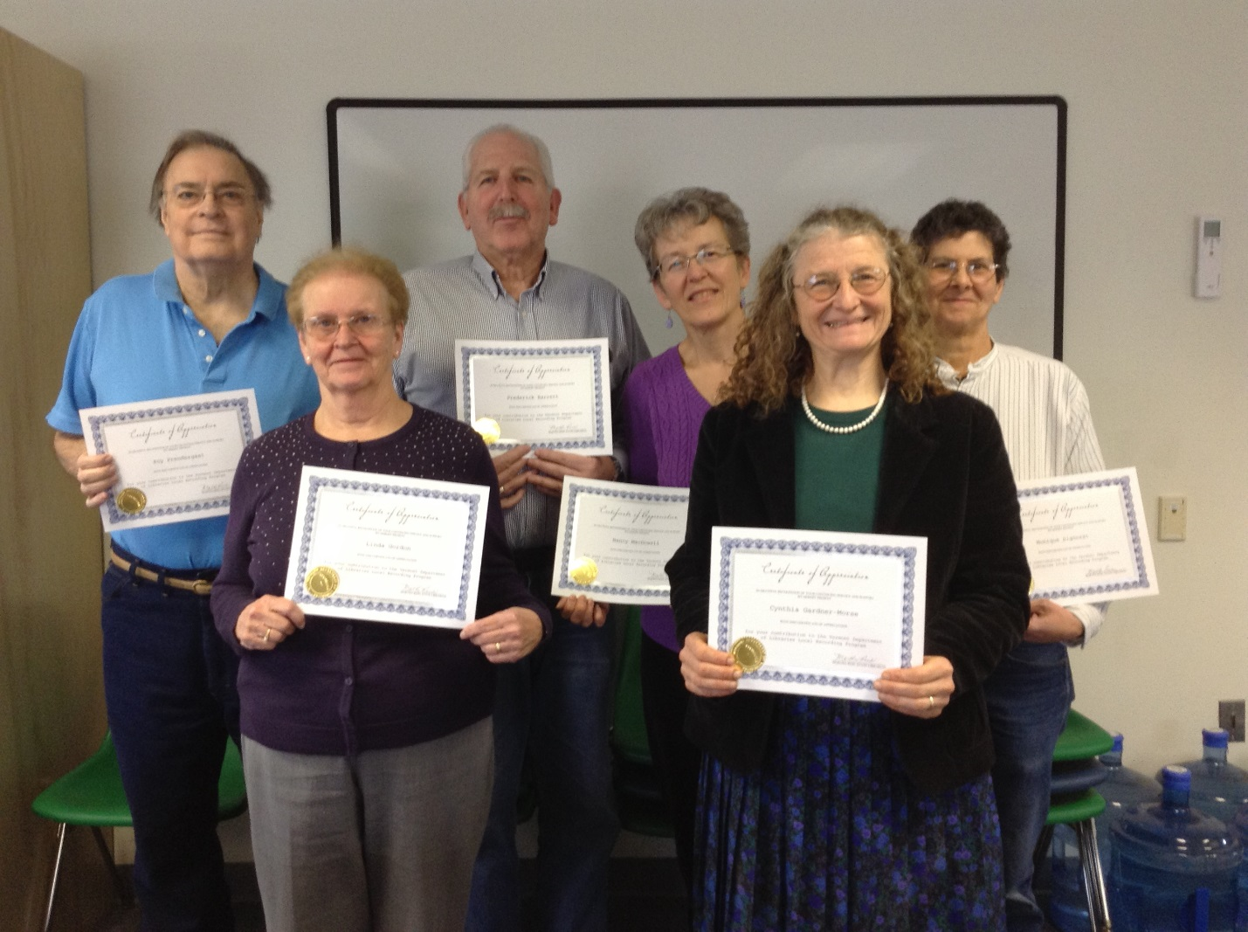

Pictured above are local recording volunteers (left to right): Roy Prendergast, Linda Gordon, Frederick Barrett, Nancy MacDowell, Cynthia Gardner-Morse, and Monique Signorat. Missing from photo: Sheena Macpherson.
More New Titles from Our Collection

Adult Fiction:

The Nightingale, by Kristin Hannah. DB 81189
France, 1939. Vianne Mauriac sends her husband off to war, while her younger sister, Isabelle, runs off to Paris, claiming an affair. Once there, Isabelle becomes involved in the Resistance. Bestseller.

The Nature of the Beast: A Three Pines Mystery, by Louise Penny. DB 82697
Nine-year-old Laurent Lepage, who is prone to telling tall tales about things he finds in the woods surrounding Three Pines, is found murdered. What discovery had he tried to share that they all, especially the retired head of homicide, Armand Gamache, ignored?

Adult Nonfiction:

When Books Went to War: The Stories That Helped Us Win World War II, by Molly Guptill Manning. DB 80928
Attorney describes the Victory Book Campaign during World War II, which provided American soldiers with selected literature of note in the face of Nazi censorship and destruction of books.

Concussion, by Jeanne Marie Laskas. DB 83314
Journalist expands upon her 2009 "GQ" article about young forensic pathologist Dr. Bennet Omalu's discovery while autopsying fifty-year-old Mike Webster -- aka "Iron Mike" -- the Hall of Fame center for the Pittsburgh Steelers. He determined that Webster's mental deterioration was a disease caused by blows to the head during football. Movie tie-in.

Children’s Books:

Animal Helpers (A True Book Series), by Susan Heinrichs Gray. DB 81097
Six books feature true animal stories and explain their unique abilities to assist humans. For grades 3-6.

Public School Superhero, by James Patterson. DB 81488
In Kenny Wright's active imagination, he's world-famous superhero Stainlezz Steel. However, in the real world, he's a sixth grade "grandma's boy" who struggles to fit in at his city school while searching for his own unique inner strength. For grades 3-6.

Vermont Humanities Council Announces
2016 Vermont Reads Books

The Vermont Humanities Council has announced its 2016 selections for Vermont Reads, Vermont’s statewide, one-book community reading program.

The Endurance: Shackleton’s Legendary Antarctic Expedition, by Caroline Alexander. DB 47531, LP 47531
Chronicles the survival of Ernest Shackleton and his crew of 27 men marooned on ice floes off the coast of Antarctica in 1915. Recounts the entrapment and later destruction of their ship, the Endurance, by pack ice and the hardships the men suffered before their rescue in 1916.

Shipwreck at the Bottom of the World, by Jennifer Armstrong. DB 49029
An account of the survival of Ernest Shackleton and his 27-man crew whose ship, the Endurance, was marooned in pack ice during an expedition to Antarctica. Explains the daily difficulties the men faced during their nine-month ordeal.

Vermont Reads Shackleton will afford Vermonters the opportunity to consider, among other things, the power of vision, courage, and perseverance; the nature of leadership; and the spirit of adventure and exploration. 2016 is the 100th anniversary of the climactic and dramatic conclusion of the Endurance expedition (1914-1916).

Three New Magazines Available

Three new audio magazines are now available for download via BARD or by calling us to add a subscription to your account. They are: AARP The Magazine and AARP Bulletin (bundled); O, The Oprah Magazine; and Rolling Stone.

Medicare Fraud Guide Available in Audio

The Community of Vermont Elders (COVE) has made available an audio guide to Medicare Fraud – how to recognize it, what to do about it, and even how to volunteer to prevent future fraud. Please contact us if you would like to borrow a copy.

New Library Hours and Voicemail

We now have reduced hours for walk-in service. We are open Tuesday, Wednesday and Thursday from 9:30am to 3pm; closed Monday and Friday. We are still open for telephone service Monday through Friday, 7:45am to 4:30pm, at 802-828-3273 or
1-800-479-1711. If we are unable to get to the phone we do have voicemail, so it’s fine to leave us a brief message, including book requests, any time of the day or night. Please make sure you include your name, reason for calling, and phone number if you require a return call.

By My Eyes – Featured App

The Be My Eyes app assists visually impaired users by connecting them with sighted helpers. By utilizing direct video call technology, the visually impaired individual can point a device’s camera at an item or area and the sighted individual can help by reading the information on the product or guiding the visually impaired individual in locating an item. This app is useful in navigating new surroundings or reading expiration dates on perishable items or medicines. Be My Eyes is currently available for Apple devices only.

Spread the Word!

If you know of anyone who may qualify and benefit from our services, please give them our phone number (802-828-3273 or 1-800-479-1711). We work hard at promoting our services, but we can always use your help and support with spreading the word!

Holiday Closings

Memorial Day – Monday, May 30
Independence Day – Monday, July 4
Bennington Battle Day – Tuesday, August 16
Labor Day – Monday, September 5

Important Phone Numbers

Vermont Division for the Blind and Visually Impaired – 802-241-0328, toll-free 888-405-5005
Vermont Association for the Blind and Visually Impaired – 802-863-1358, toll-free 800-639-5861
Learning Ally – toll-free 800-221-4792

Vermont Department of Libraries, Special Services Unit
1-800-479-1711 or (802) 828-3273
Monday-Friday, 7:45 am to 4:30 pm
Email lib.ssu@vermont.gov
Website libraries.vermont.gov/library_for_the_blind
Online catalog webopac.klas.com/vtssu
This newsletter is available in alternative formats upon request.
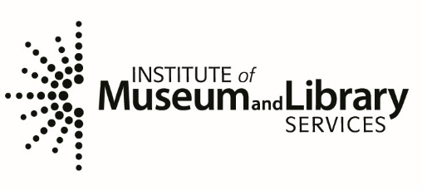

This program is supported in part by the
Institute of Museum and Library Services, a federal agency, through the
Library Services and Technology Act.

