CLOVER: Frequently Asked Questions (FAQs)

- Can you choose which lenders to borrow from?
  - Yes, you can create what is called a “Preferred Lender List” within your “Participant Record.” From this list, CLOVER randomizes requests so they are spread as fairly as possible across libraries.

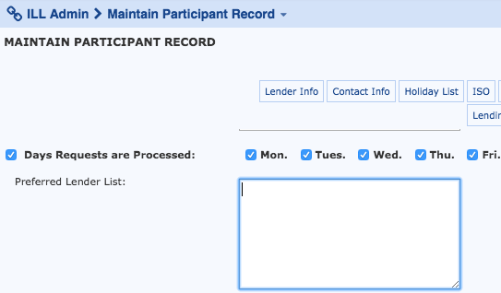

- What if you are unable to fill a request through all preferred lenders?
  - The Vermont Department of Libraries is the lender of last resort and will appear at the very end of each and everyone’s “Preferred Lender List.” If an item cannot be found in any Vermont Library, the item will be requested from somewhere outside of the state.

- When searching for an item, what if nothing comes up?
  - There is a tab called “Blank ILL Request” located at the top of the CLOVER homepage in which you are encouraged to fill out as many details as possible.

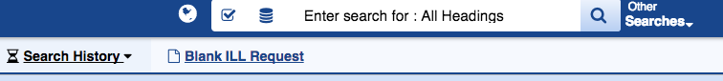

- How do you make a multiple copy request for a book group?
  - When requesting an item, there is a “Multi-Copy” tab on the top right side of the “Item Record” page. To get to the “Item Record” page, click on the item. For example, in the image below, you would click on the cover page of “A Man Called Ove.”

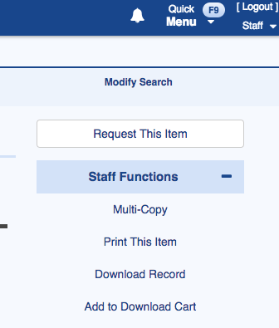

- When an item is borrowed, where does the due date appear?
  - Due dates are generated from the CLOVER system for each item request and can be printed on a slip to be attached to an item ready to be sent out.

- Is there a place to add notes about an item when submitting a request?
  - Yes, there is a “Borrower’s Notes” located under the the patron’s information.

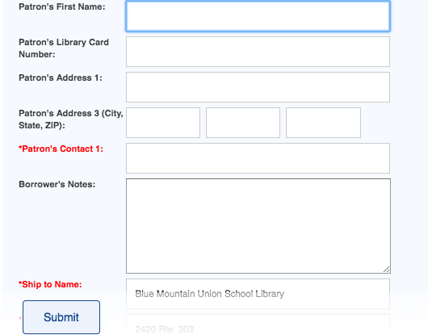

- Can email notifications be generated?
  - Yes, there are various settings you can customize for notifications within the “Request Manager” Tab from the “Staff Dashboard.”

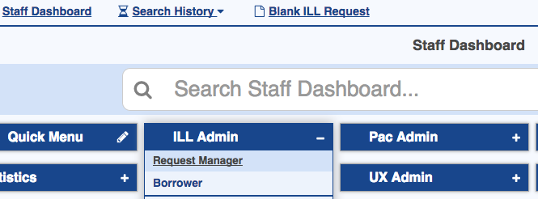

- As a lender, how do you notify borrowers that you cannot lend for a period of time?
  - In the “Participant Record”, you can adjust the “Holiday List.”

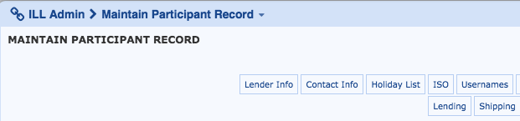

- When filling out a request, how much patron information do you have to manually key-in?
  - Once your local ILS is connected with CLOVER, the patron information will auto-populate after you enter a patron’s name in a borrowing request. In the image below, “Patron’s Last Name” has an asterisk next to it which means that it is a mandatory field. Once a name is in that field, the rest of the patron details will appear in the boxes. Note: Lenders can only see the patron’s name.

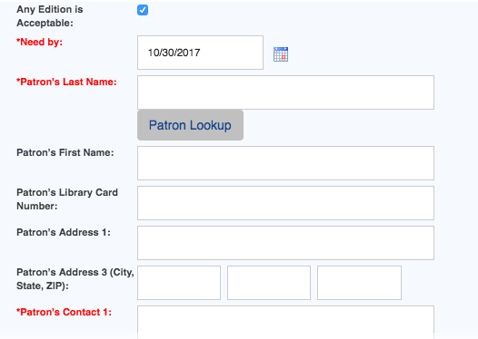

- When a lender receives multiple requests, can a list be printed to retrieve the items?
  - Yes, when a lender has multiple requests from other libraries, they accumulate into a list called a “pick list.” This list can be generated and printed in the top right corner.
