Winter/Spring 2018
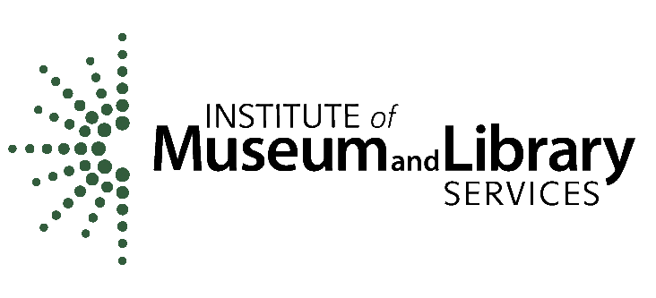
-Youth Services Workshops-

February
Annual Summer Reading Workshop

Northern session:
Get inspired for the 2018 Libraries Rock! Summer Reading program! You will be able to listen to a variety of short presentations, meet local partners, and brainstorm programming ideas with your fellow youth services librarians.

*Waterbury Public Library
*Wednesday, February 7, 2018 – 9:30-2:00pm
*Snow Date: Wednesday, February 21, 2018

Southern session:
*Rockingham Free Public Library
*Tuesday, February 13, 2018 – 9:30-2:00pm
* Snow Date: Tuesday, February 20, 2018
March
Storytime Refresher Workshop

Northern session:
Need some ideas to liven up your storytime? Never done a storytime before? All are welcome to this workshop that covers the basics of Baby, Toddler, Preschool, and Family storytimes. Best practices will be discussed, and there will be plenty of time to share programming ideas.
*Stowe Free Library
*Tuesday, March 13, 2018 – 9:30-2:00pm
*Snow Date: Tuesday, March 20, 2018

Southern session:
*Manchester Community Library
*Friday, March 9, 2018 – 9:30am-2:00pm
* Snow Date: Friday, March 16, 2018
April
Afterschool Workshop

Northern session:
Need some inspiration on what types of programs might work for your afterschool crowd? Have some issues “containing” the enthusiasm of your afterschool crowd? Come hear a panel of experts talk about ideas and strategies. There will be plenty of time to discuss ideas and issues you might have at your library.
programming ideas.
*St. Johnsbury Athenaeum
*Tuesday, April 3, 2018 – 9:30-2:00pm
*Snow Date: Tuesday, April 10, 2018

Southern session:
*Bennington Free Library
*Thursday, April 5, 2018 – 9:30am-2:00pm
* Snow Date: Thursday, April 12, 2018

But wait! There’s more on the other side…
Winter/Spring 2018
-Youth Services Workshops-

Materials Review Workshop

(One Session Only)

March 2018 – Date TBA – 9:30am-2:00pm
Midstate Regional Library – Berlin, VT

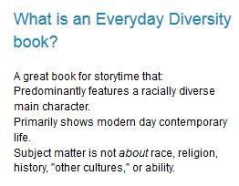

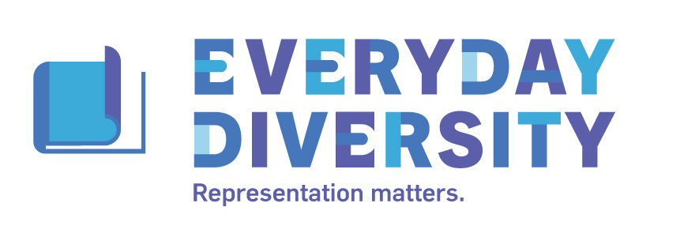

This workshop is designed for those who are interested in helping Cass review books for her upcoming, biannual materials review sessions and her monthly emailed lists. Learn how to prepare a short review with hands-on practice and learn to determine which materials are useful in your collection. Cass will also discuss Everyday Diversity and how it can easily be applied to your collection. All are welcome regardless of interest in reviewing for Cass. Special guests Grace Greene and Leda Schubert will also be present to give their tips & tricks!

But wait! There’s more on the other side…

