July 20 - September 9



Find it on 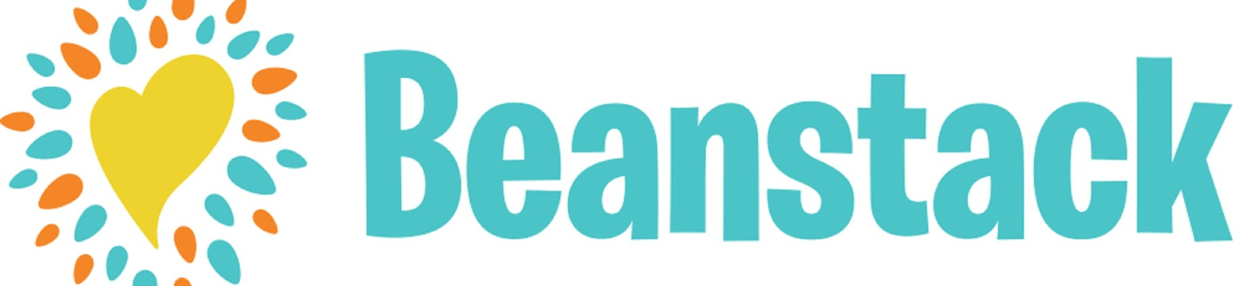

vermont.beanstack.org

Sponsored by:

 