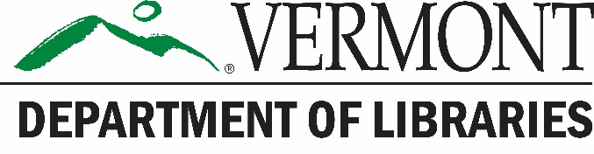 | Resources that Patrons  Can Access Remotely

Resources provided by the Vermont Department of Libraries to All Public Libraries:

Universal Class
More than 500 online classes ranging in topics from writing skills, software programs (including Adobe and Microsoft programs), to science, html, and graphic design. There's something for everyone! Though classes are not for college credit, they are led by a real instructor with whom you can communicate by e-mail. Courses allow you to proceed at your own pace, working on assignments anytime, day or night.
Access – Go to http://bit.ly/vtlib_uc and use your library card number to login and create an account.

Learning Express
Learning Express library is a deep and broad tool that has something for everyone! It covers elementary school homework help, prep for the Commercial Driver’s License (CDL) exam, nursing and medical testing prep, job interview and resume writing, computer skills, SAT, LSAT, and GRE test prep, to interactive tools to help someone choose a career. It can help someone choose a pathway in life or provide the tools to get a better job.
Access – Use the link on your library’s website and create an account.

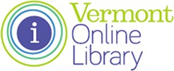
Vermont Online Library
Covering everything from newspaper articles to DIY car repair, the Vermont Online Library (VOL) can help with any topic. Available for free to all Vermonters, VOL has options for all ages from elementary school through adult. You can even use it to read current articles from the NY Times, Washington Post, the Economist, and more.
Access – Use the link on your library’s website. It will ask if you share your location; if not, login with your library card number or a password (ask library staff).

Free Resources:

Internet Archive
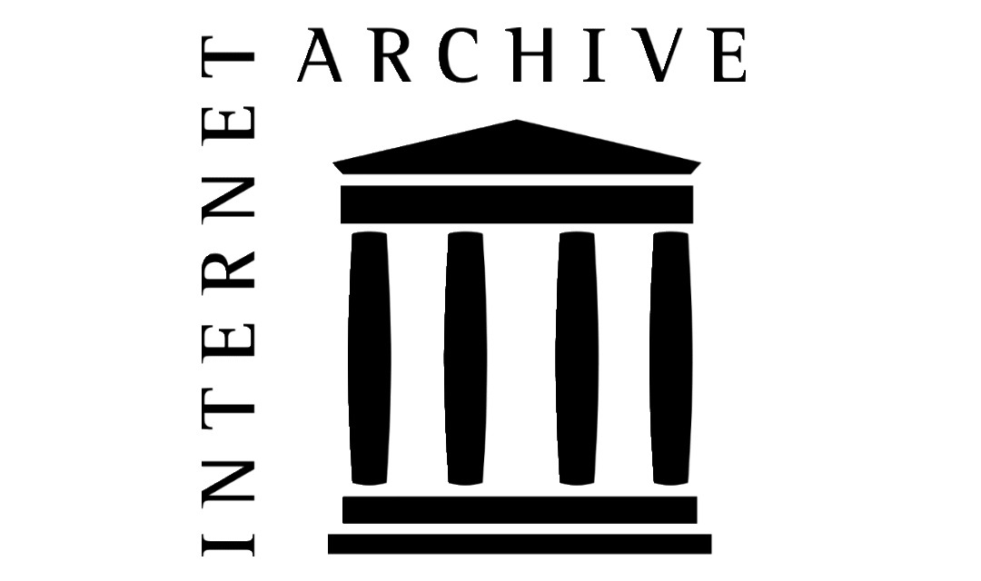
Internet Archive is a non-profit digital library offering free universal access to books, movies & music, as well as 418 billion archived web pages.
Access – Go to https://archive.org/

Project Gutenberg
The site offers thousands of public domain ebooks for free use on any device. Because they are public domain, they are typically limited to items published before 1924, but that still includes a wide range of classics.
Access – Go to https://www.gutenberg.org/ and download ebooks in a variety of formats

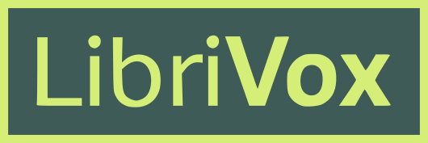
LibriVox
This site offers public domain audiobooks recorded by volunteers for free use on any relevant device. Like Gutenberg, they tend to be items published before 1924.
Access – Go to https://librivox.org/ and download audiobooks.

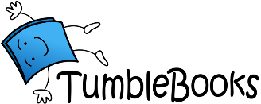
TumbleBooks
This site offers is a collection of animated talking picture books, read-alongs, ebooks, quizzes, lesson plans, and educational games. They recently announced its online products would be available for free to all public libraries until at least August 31.
Access – Libraries need to email info@tumblebooks.com with subject line Free TumbleBooks in order to receive free links to all three TumbleBook databases for use by their patrons.

FamilySearch
This free genealogy site allows users to search for information, create a family tree, and pull records from their extensive database.
Access – Go to https://www.familysearch.org/

Available through some Public Libraries (Please contact your local library for availability):

Overdrive
Overdrive allows you to check out ebooks and digital audiobooks to your phone, tablet, or other device. Just like print books, there’s a checkout period, and only one person can have a book at a time.
Access – Install the Libby app, or go to the appropriate link for your library. You’ll need your library card number and possibly your password to get logged in.

Hoopla
Hoopla offers ebooks, comics, audiobooks, music, movies and TV shows. Items can be streamed to computers or mobile devices. Items are always available, though patrons are limited to how many they can view in a month.
Access – Go to http://www.hoopladigital.com/ and enter your library card number to create an account.

Kanopy
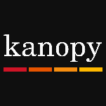
Kanopy offers users the chance to stream a wide range of films. Items can be viewed on mobile and other devices. Items are always available, though patrons are limited to how many they can view in a month.
Access – Follow the link on your library’s website and use your library card number to create an account.

Acorn TV
Acorn TV offers British television for streaming on a range of devices. Access is unlimited.
Access – Follow the link on your library’s website and use your library card number to register.

