Library Phased Reopening/COVID-19 Template and Exposure Control Plan

This template is adapted from the one provided by VOSHA and posted on the ACCD website to put it in context for libraries. VTLIB provides this template as a guide for those libraries that would like to adapt it to meet their needs. Using this specific template is neither mandatory nor required.

Library Name
Director
Contact Email Address

Sections
- Introduction
- Responsibilities
- Exposure Determination
- Hazard Reduction
- Recommended/Mandatory Requirements (until 7/4/21)
- Employee Training
- Phased Reopening Details

- INTRODUCTION

Purpose: The purpose of this policy is three-fold:

- To continue to protect the health and safety of our library workers and by extension their families.
- To implement the requirements and/or recommendations of the Vermont Department of Health, Centers for Disease Control and Prevention (CDC) Guidelines, Vermont Occupational Safety and Health Administration (VOSHA) and the Vermont Agency for Commerce and Community Development (ACCD). Using the measures provided by these agencies, our library will strive to protect the health of our employees. This program will document the measures we use to comply with the provided guidelines.
- To explain the phased reopening steps the library plans to take.

Definitions: COVID-19 - COVID-19 is a respiratory disease spread from person to person. SARS-CoV-2 is the virus that causes COVID-19.

- RESPONSIBILITIES

Health Officer (recommended – not required): All libraries should consider having a designated Health Officer for all shifts to assess whether employees are presenting symptoms and, if so, to send them home.

- This person is responsible for ensuring compliance with the Executive Order and the Addenda thereto, as well as applicable ACCD Guidance and the VT Forward Plan.
- This person shall have the authority to stop or modify activities to ensure work conforms with safety guidelines and requirements.

Name of Health Officer(s) | Shift(s)

Administrative Person: This may be the Health Officer. This person will be responsible for the administration of the following plan.

- Assess the hazards in the library (see Hierarchy of Controls in this document)
- Administer and update this program as necessary
- Regularly review guidance from Agency of Commerce and Community Development
(ACCD) and check for updates
- Review the effectiveness of this program
- Participate in any investigation of employee complaints or failure to comply with library rules
- Provide effective training on COVID-19 and the preventive measures the library has taken and that the employee must follow

Administrative Person

Department Managers:

- Ensure that all employees follow the protective measures outlined in this program
- Enforce compliance with this program using the existing disciplinary structure of library
- Ensure training for COVID-19 protections has been completed and documented

Employees:

- Follow all rules and practices, including, but not necessarily limited to:
  - Participate in all trainings relative to COVID-19
  - Stay home if you are sick
  - Wash hands frequently
  - Practice Social Distancing – 6 foot minimum
  - Report to your HR person if you feel sick, have a temperature, or you have had close contact with a person suspected of having COVID-19
  - Wear protective PPE as required
  - Wear protective cloth mask as required

- EXPOSURE DETERMINATION

General Information: This information is provided by the Vermont Dept of Health, CDC Guidelines and VOSHA:

- High Risk: Workers in some sectors have a high risk of occupational exposure to COVID-19, including in:
- Healthcare and Laboratories, emergency response, mortuary services and other death care, airline operations, border protection and passenger screening, and critical retail operations (e.g., grocery stores, pharmacies).

- Medium Risk: Workers that are in a medium exposure risk are jobs that require frequent (i.e. more than a few minutes) and/or close (i.e., within 6 feet) contact with people who may be infected with SARS-CoV-2, but who are not known or suspected COVID-19 patients. Examples include:
- Critical retail workers (such as those in pharmacies and grocery stores), transit workers, (such as bus drivers, subway operators, and taxi drivers), and workers in other transportation operations.

- Low Risk: Workers that are in a low exposure risk are jobs that do not require contact with people known to be or suspected of being infected with SARS-CoV-2, nor frequent close contact with (within 6 feet) of the general public:
- Workers in this category have minimal occupational contact with the public and other coworkers.

Department of Libraries Note: In the context of library work, examples for the three different levels could include:
- High risk: helping a patron on the computer while being in relatively close contact;
- Medium Risk: conducting quick transactions at the front desk; and
- Low risk: being in the back doing cataloging with no patron interaction or providing contact-free curbside service.

Assessment: The first step the library has taken is to conduct a hazard assessment to determine our risk level and exposure potential. The following was determined.

Exposure Risk Level | Positions
High
Medium
Low

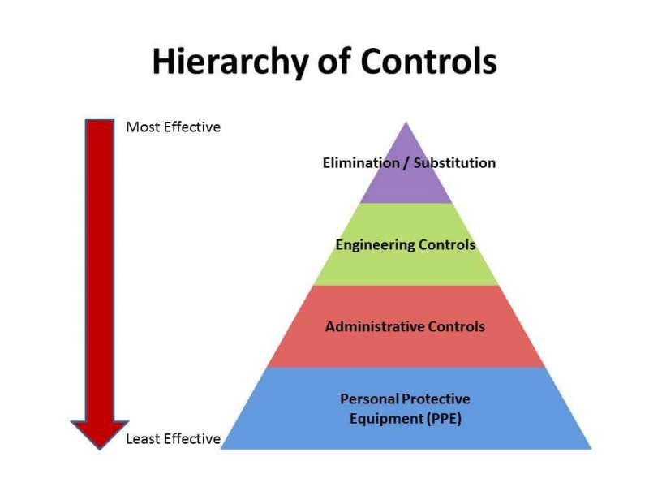
- HAZARD REDUCTION

As with all hazards, it is this library’s goal to eliminate the hazard if possible. Using the Hierarchy of Controls and the VOSHA guidelines it is our goal to minimize the hazard.

Elimination/Substitution: We have reviewed our tasks - the following practices have been evaluated:
- Working Remotely/Staggered Scheduling – If workers cannot maintain 6’ distancing, arrangements have been made to allow staggered scheduling or remote work
- Meetings and trainings conducted via internet, phone, or other electronic means
- Client-patient services done via internet, phone, or other electronic means
- Other

The practices that this library has eliminated and replaced with alternative methods are:

Practices Eliminated or Replaced

Engineering Controls: We have reviewed our tasks - the following suggested controls have been evaluated:
- Physical barriers to prevent spread – i.e. workstation barrier such as sneeze guards
- Isolation of tasks
- Employee to employee contact reduced by spreading out workstations
- Ventilation patterns and air change rates
- Other
Engineering Controls Implemented

Administrative Controls: We have reviewed our tasks - the following Administrative Controls have been evaluated:
- Training
- Behavior Modification - Social distancing of 6 feet apart
  - Personal Cleanliness: Hand washing
  - Require employees to wipe down their area after use
- Work Surface Cleanliness
  - Wipe down surfaces such as door push bars, book drop handles, chairs, and other areas that patrons or workers frequently touch
- Employee self-monitoring - stay home if feeling ill
- Temperature testing
- Staggered work shifts and break times to reduce employee and public contact
- Limit staff travel between multiple sites
- Implement a safe process to receive supplies and deliveries

Administrative Controls Implemented

Personal Protective Equipment: General Information:

- Gloves: various gloves protect against varying hazards; most commonly, medical grade Nitrile or latex gloves are used to protect against pathogenic hazards.
- Face shields and/or Sneeze Guards: provide a physical barrier to others.
- Face Mask – Cloth and/or disposable: have been determined to be helpful in protecting others from coughing, sneezing or spraying droplets when talking.

https://www.cdc.gov/coronavirus/2019-ncov/prevent-getting-sick/diy-cloth-face-coverings.html

- RECOMMENDED/MANDATORY REQUIREMENTS (until 7/4/21)

The following are recommended (or in some cases, mandatory) requirements from the State of Vermont. In each case, a staff member is listed as being responsible for researching and accomplishing the goal. Universal Guidance: https://accd.vermont.gov/covid-19/universal-guidance

Face Coverings (Mandatory): Employees must wear face coverings over their nose and mouth when in the presence of others. In the case of retail cashiers, a translucent shield or “sneeze guard” is acceptable in lieu of a mask.

How Have We Accomplished This?
Responsible Person

Distancing and Face Touching (Mandatory): All employees must observe strict social distancing of 6 feet while on the job, unless noted, and should refrain from touching their faces.

No congregation of employees is allowed.

How Have We Accomplished This?
Responsible Person

Break Room: If possible, common areas, break, or lunch rooms should be controlled. If the nature of the work or the work area itself does not allow employees to safely consume meals in the workspace, an employer may designate a common area or room where meals may be safely consumed provided all of the following conditions are met:
- The library shall limit occupancy of designated common area or room so that occupants maintain strict social distancing of no less than 6 feet per individual.
- The library shall enforce the occupancy limit as determined by the library director and trustees.
- Hand washing facilities and/or hand sanitizer shall be immediately available at entrances of the designated common area or room.
- Employees shall be required to wipe down their area prior to leaving - or there shall be cleaning of the area at regular intervals throughout the day.
- At the entrances of the designated common area or room, the library shall clearly post the policy limiting the occupancy of the space, and the minimum social distancing, hand washing/hand sanitizing and space cleaning requirements.

How Have We Accomplished This?
Responsible Person

Airflow and Occupancy: When working inside, promote air flow to the greatest extent possible and limit the number of people occupying a single indoor space.

How Have We Accomplished This?
Responsible Person

Vehicle Occupancy: No more than 3 people shall occupy one vehicle when conducting work, and shall wear face coverings when riding together.

Department of Libraries Note: You may enter N/A if there is no vehicle-based work through the library.

How Have We Accomplished This?
Responsible Person

Cleaning/Disinfecting (Mandatory): All common spaces and equipment, including bathrooms, frequently touched surfaces and doors, tools and equipment, and work-purpose vehicles must be cleaned and disinfected at the beginning, middle and end of each shift and, when possible, prior to transfer from one person to another. https://www.cdc.gov/coronavirus/2019-ncov/community/disinfecting-building-facility.html

Supplies
Outside Vendor (if relevant)
Cleaning Schedule
Responsible Person

Soap and Sanitizer (Mandatory): Employees must have easy and frequent access to soap and water or hand sanitizer during the duration of their work, and handwashing or hand sanitization is required frequently including before entering, and leaving job sites.

How Have We Accomplished This?
Responsible Person

Patron Masks (Mandatory): Libraries shall ask patrons to wear face coverings any time they are interacting with others from outside their household.

How Have We Accomplished This?
Responsible Person

Signage: Signs should be posted at all entrances clearly indicating (1) that no one may enter if they have symptoms of respiratory illness, (2) building occupancy limits, and (3) mask expectations. https://accd.vermont.gov/covid-19/business/restart/signage

How Have We Accomplished This?
Responsible Person

Employee/Volunteer Screening: To the extent feasible, prior to the commencement of each work shift, prescreening or survey should be completed to verify each employee/volunteer has no symptoms of COVID-19. Symptoms include the following:
- Cough
- Shortness of breath or difficulty breathing
- Fever (>100.4ºF or subjective fever)
- Chills
- Muscle pain or aches
- Headache
- Sore throat
- New loss of taste or smell
- Congestion or runny nose
- Nausea or vomiting
- Diarrhea

How Have We Accomplished This?
Responsible Person

Sick/Exposed Employees/Volunteers (Mandatory): Employees/Volunteers shall not report to, or be allowed to remain at, work or job site if sick or symptomatic (with COVID-19 symptoms – see list above).

Unvaccinated employees who have not had COVID-19 in the past 90 days and have had close contact for more than 15 minutes with any person who is diagnosed with COVID-19 are required to quarantine for 14 days or for 7 days prior to obtaining a COVID-19 test.

How Have We Accomplished This?
Responsible Person

- PHASED REOPENING DETAILS

The library board of trustees, working with the library director, the Town(s) supporting the library (if applicable), and other stakeholders have developed a series of reopening phases. Those phases are detailed below, including information about the conditions required for each phase to start, the services offered at each stage, and any other pertinent details.
The library notes that progress through these phases may need to be fluid, depending on conditions in Vermont and any future recommendations or requirements from the Governor, ACCD, CDC, and other authorities.

Communication Plan: The library will use the following methods to communicate to the public and stakeholders which phase the library is currently operating under (select applicable methods):
- Email
How Have We Accomplished This?
Responsible Person
- Webpage Updates
How Have We Accomplished This?
Responsible Person
- Facebook
How Have We Accomplished This?
Responsible Person
- Front Porch Forum
How Have We Accomplished This?
Responsible Person
- Paid Advertisements/Announcements
How Have We Accomplished This?
Responsible Person
- Community Boards
How Have We Accomplished This?
Responsible Person
- Radio/TV Spots
How Have We Accomplished This?
Responsible Person
- Other Methods
How Have We Accomplished This?
Responsible Person

Department of Libraries Note: Which services each library provides at each stage should be based on the specifics of the following:
- your building capacity,
- your staff/volunteer capacity,
- safety requirements/recommendations from the State,
- budget restrictions,
- community needs,
- and any other factors specific to your community and your library.

Potential Example Phases (provided only as examples; your library’s situation may require different phases):
- Building closure, online/email, phone, and mail services only. No book returns.
- Building closure, curbside/delivery services added. Book returns taken.
- Building partial reopening. Patron access by appointment only for a maximum of ___ minutes. Maximum of ___ patrons allowed in the building. Book browsing allowed/not allowed. Public access computers allowed/not allowed. Distancing signage and behavior policies posted. No library programming.
- Building partial reopening. Maximum number of patrons allowed in the building increased to ____. Book browsing allowed. Public access computer usage allowed. In person library programming starts with a maximum of ___ patrons per program (because of space restrictions/requirements).
- Building fully reopened.

PHASE ONE:
Conditions Required for this Phase to be In Effect:
Description of Phase:
Services Offered:
Maximum Number of Patrons Allowed in the Library Building:
Staffing Requirements for These Services:
Safety Measures Taken:

PHASE TWO:
Conditions Required for this Phase to be In Effect:
Description of Phase:
Services Offered:
Maximum Number of Patrons Allowed in the Library Building:
Staffing Requirements for These Services:
Safety Measures Taken:

PHASE THREE:
Conditions Required for this Phase to be In Effect:
Description of Phase:
Services Offered:
Maximum Number of Patrons Allowed in the Library Building:
Staffing Requirements for These Services:
Safety Measures Taken:

PHASE FOUR:
Conditions Required for this Phase to be In Effect:
Description of Phase:
Services Offered:
Maximum Number of Patrons Allowed in the Library Building:
Staffing Requirements for These Services:
Safety Measures Taken:

