CLOVER/SHAREit ILL Request Procedure

Go to your library-specific CLOVER/SHAREit URL:
http://vtlib-agent.auto-graphics.com/mvc/?cid=vtlib&lid=xxxxx&reset=force

You must replace xxxxx with your CLOVER/SHAREit library code (example: P77)

To Login:
Click Login (upper right corner of opening screen)

The login window will open and it should default to your library
(in the “Select your library” drop-down menu)

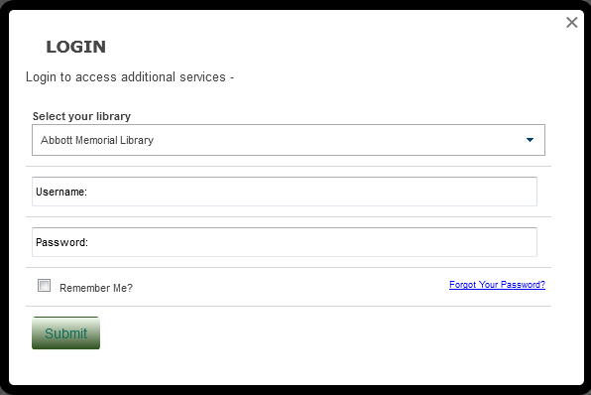

Input your username and password in the provided boxes
Click the Submit button
Search to find the item you wish to borrow

You may search by utilizing different search indexes. Click the checkmarkto see all available index options; “All Headings” (i.e., keyword) search is the default

You may search one or more library catalogs. Click the Database Selector to see the available catalogs

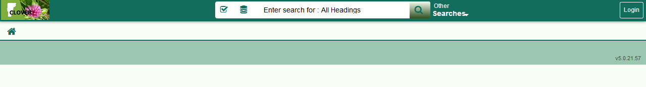

Select all Library Catalogs to retrieve the greatest number of results.

Click the checkbox at the top of the list to select all library catalogs:

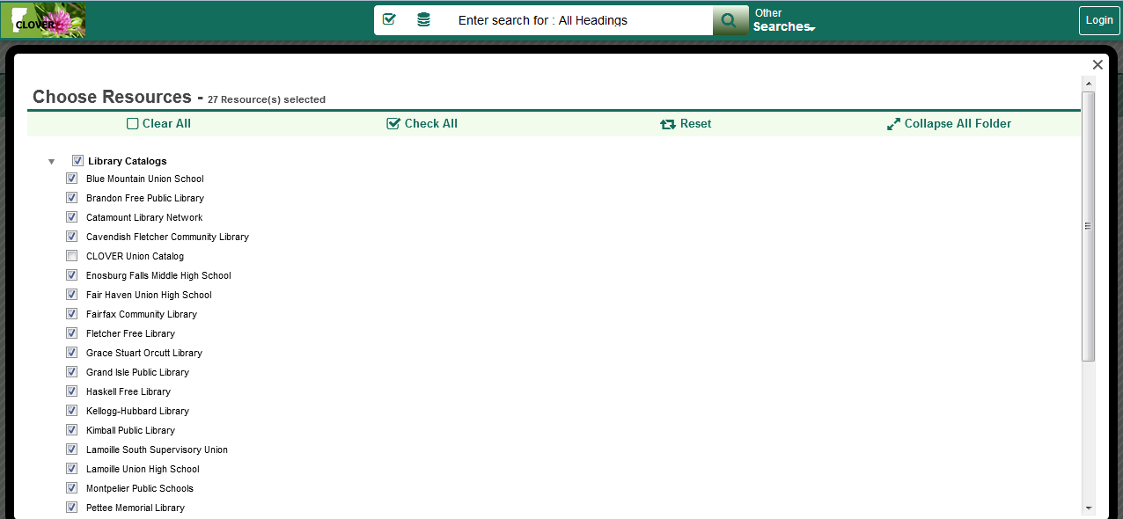

After selecting desired library catalogs, input search term(s) into search field and click the SEARCH icon (magnifying glass) to begin search:

Search results will look similar to this:

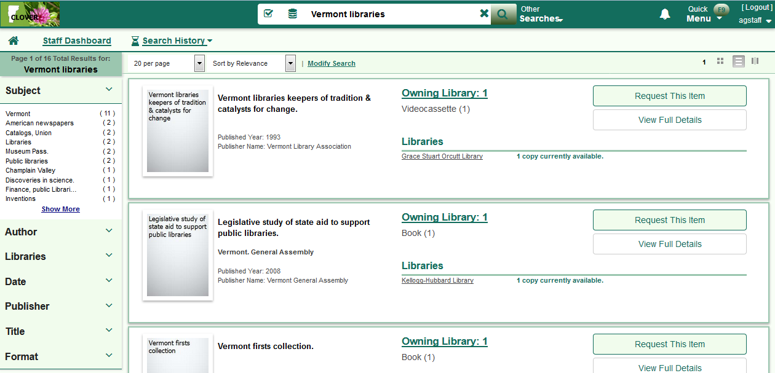

Click Request This Item to place an ILL request:

The ILL form will open. You may see a message like this if your library owns the item being requested:

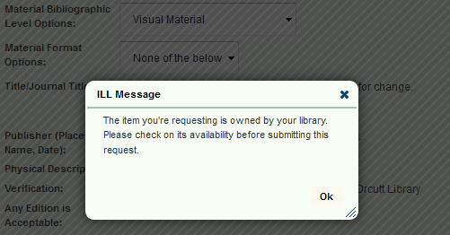

Acknowledge message by clicking OK
Fill in all required fields (i.e., patron info) in the ILL form and click Submit

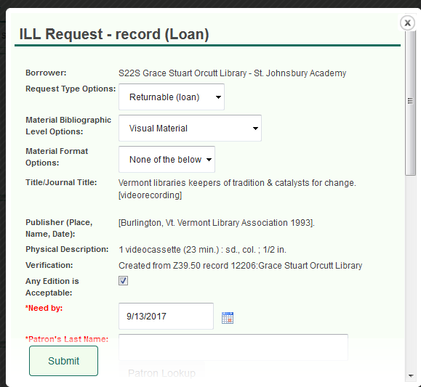

System will present a confirmation message for successful request initiation:

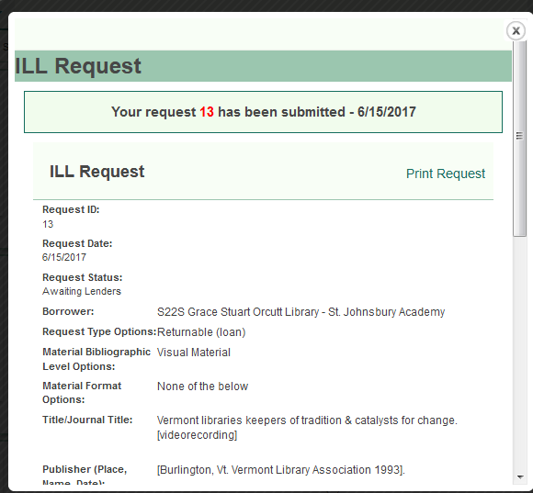
ILL request management occurs via the Staff Dashboard in the ILL Admin module, typically via the Request Manager screen:

